VITE(or SPEED in )
It’s a Next Generation Build Tool That Offers Instant Project Startup and RealTime Updates Making Development with frameworks like react,view and etc smooth and faster
Things to Learn
- Building React App with VITE
- Working with static Assets
- Using Environment Variables Typescript Development
- Building for Production
- Configuring and extending VITE
- HMR and What makes Vite fast
INSTALLATION
VITE Requires NODE JS Version 18+ or 20+ to run
Other procedures of installing Vite with React are known
Assets folder – Is for static assets in your project that you want to optimize
Public folder – Is for static assets that you don’t want to optimize

Vite Uses Hot Module Replacements (HMR) over Native ES Modules
This means rather than bundling the entire code to serve it up to the browser when ever there is a change VITE just replaces the part of the code that got changed without Disturbing the Application State
Eg.When there is the counter and you have already counted may be to ten and then to the code you update and may be add a head and save the Head will be added while the state of the counter will remain to ten without being moved away
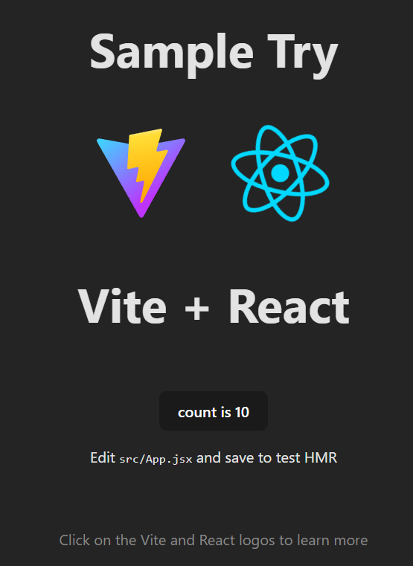
Here as you can see the new header “Sample Try” has been Added and still the Counter is “10” that’s means that the counter state was not destroyed
So vite only Updated the Header That I have ADD
WORKING WITH STATIC ASSETS
In Vite you can handle static assets like text,images and media files in one of two ways
- Optimize – in your build
- Copy As Is
OPTIMIZE
- Hash to Cache – Includes adding a hash to the file name for caching
- Inline if file < 4kb – Includes inlining the file if its size is less than 4kb
Inline - means converting the file to base64 and including it in the HTML as a separate time
This will prevent an extra HTTP Request
- Optimize with plugins
So the images which will be placed in assets folder will be optimized while the images which will be placed in public folder will not be optimized

ENVIRONMENT VARIABLES
import.meta - as a web standard to it vite adds an object called .env and in this object vite provides a number of built in context to use whict are
- .BASE_URL - This is the string that gives the base url the app is being searched from
- .MODE - This is the string that Gives the mode the app is running in it could be Development or Production or another mode
- .DEV and .PROD - This are booleand which shows weather the app is running in Development or in Production
- .SSR – A Boolean which tells weather the app is running on the server
In Addition vite also grants access to on Environment variables those can be ones that you pass throught the command line or you could provide them a file named .env in the root if your project each environment variable must start with the prefix vite underscore
Eg

VITE_DB_USER = user

VITE_DB_PASSWORD = password

And in order to use an environment variable you access it like
Eg.

const dbUrl = import.meta.env.VITE_DB_URL

Also Eg.

console.log(import.meta.env.MODE) // 'development' or 'production'

console.log(import.meta.env.BASE_URL) // url base path

console.log(import.meta.env.PROD) // true if production environment, false otherwise

TYPESCRIPT WITH VITE
BUILD FOR PRODUCTION
Top three npm scripts that you will run for production using vite
- npm run dev – This builds your app for development
- npm run build – This builds your app for production and output the build in the directory called dist
- npm run preview – This can be used to test or preview the build locally in the dist directory and show you how it will look in production

CONFIGURE WITH OPTIONS
There are many options to configure vite and configuring it we use the vite.config.js file
You can change the default port
A Have learned
- Configuring vite dev server
- Configuring build
- Configuring preview

EXTEND WITH PLUGINS
How to install plugins
- Install the plugin as a dev dependency in package.json
- Import and add it to the plugins array in vite.config.js
- Check the plugin docs for any additional configurations.
There are many vite plugins but one of the best is
- QRCode plugin – gives you qrcode so as you can see the app in your phone
- Svgr plugin – Helps you transform svg into react component

EXTRA
Other dev servers are like Webpack these is a bundle based we

